**Task 2**

**Number Converter:**

Description:

The topics we covered in this program is:

Control Structure,

If selection statement,

If else... selection statement,

Nested loop Counter statement

switch Multiple selection statement,

while iteration Statement,

Counter Control iteration,

For iteration statement,

Here is a program for numbers conversion. This program can convert Binary number, decimal number and hexadecimal number to each other respectively.

By entering choice, you can get choice for number conversion.

If user can choice 1, it will convert binary to decimal

For choice 1, it will take binary number and it will output will be in decimal number.

If user can choice 2, it will convert binary to hexa-decimal

For choice 2, it will take binary number and it will output will be in hexa-decimal number.

If user can choice 3, it will convert decimal to binary

For choice 3, it will take decimal number and it will output will be in binary number.

If user can choice 4, it will convert decimal to hexa-decimal

For choice 4, it will take decimal number and it will output will be in hexa-decimal number.

If user can choice 5, it will convert hexa-decimal to binary

For choice 5, it will take hexa-decimal number and it will output will be in binary number.

If user can choice 6, it will convert hexa-decimal to decimal

For choice 6, it will take hexa-decimal number and it will output will be in decimal number.

**Code:**

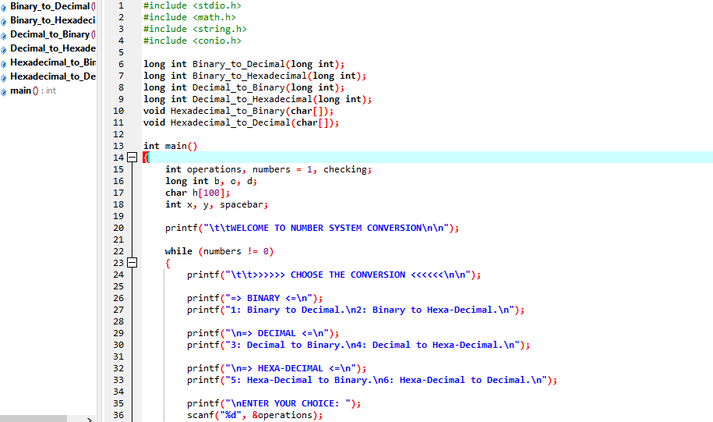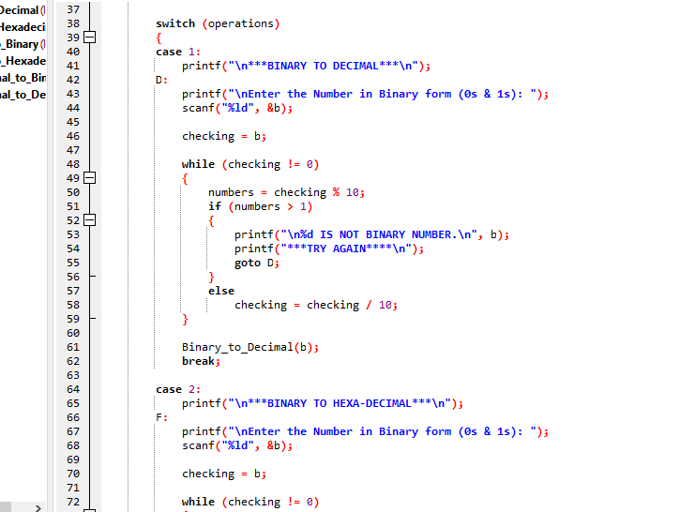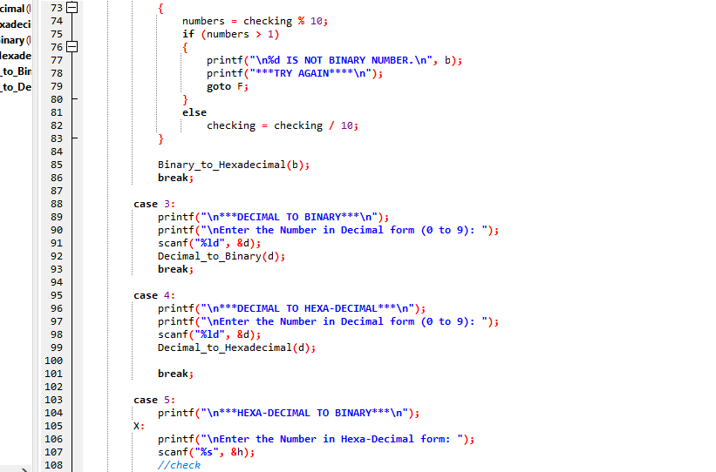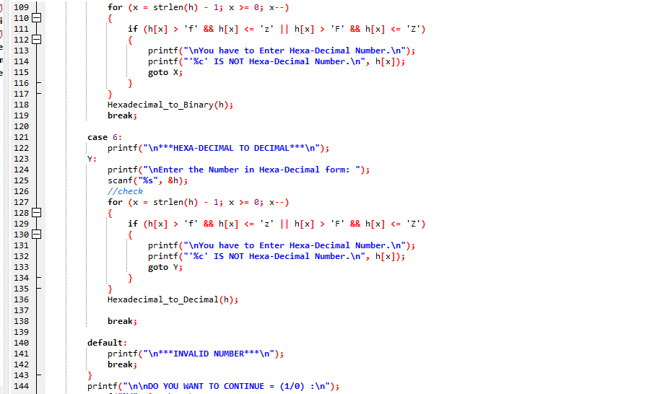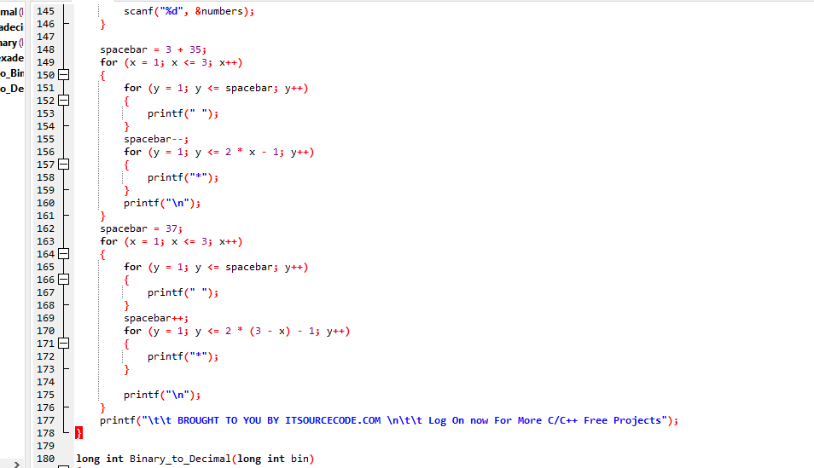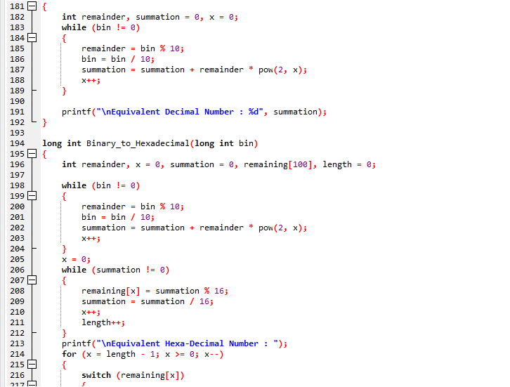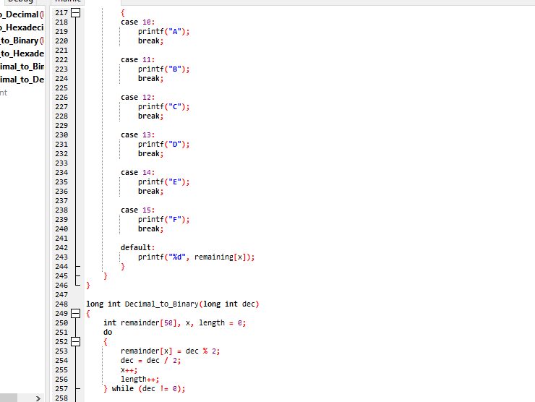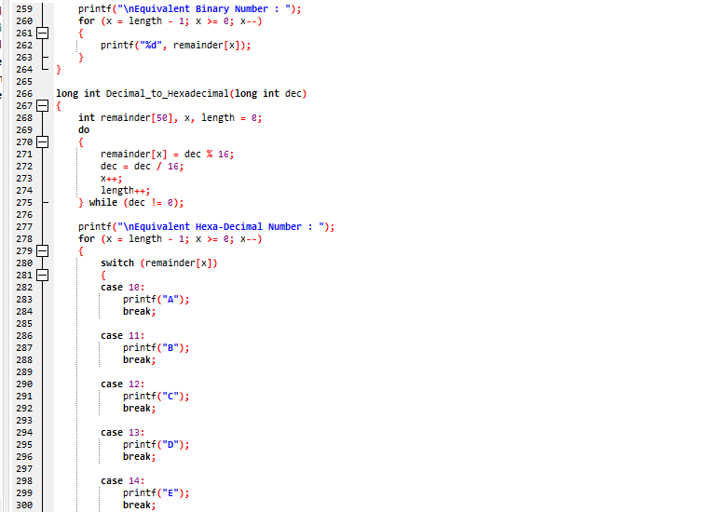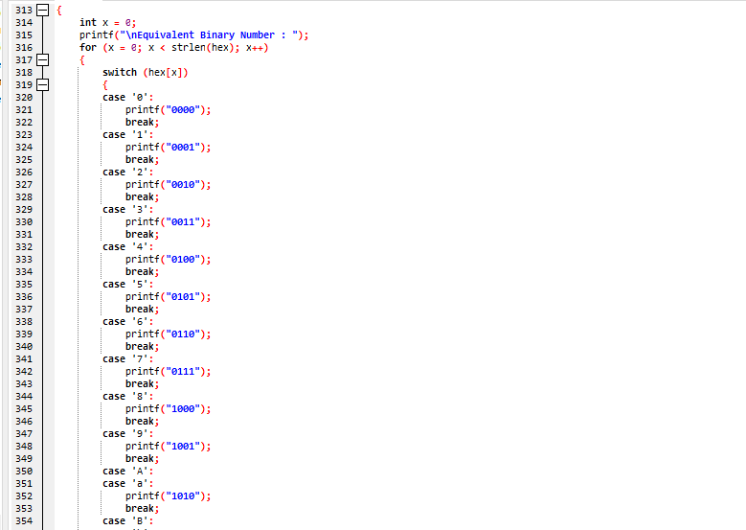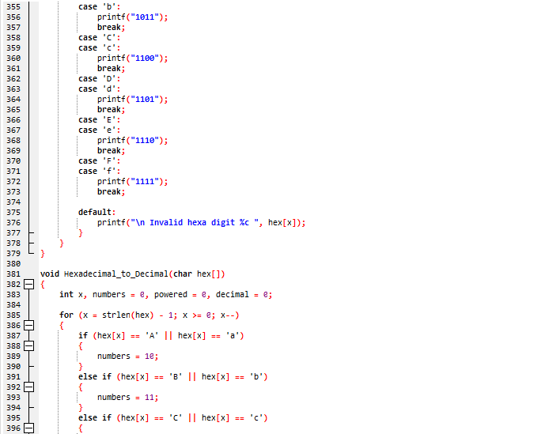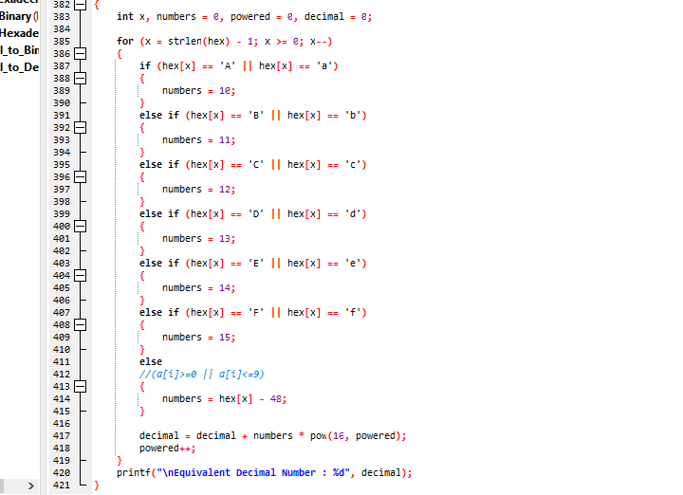

**Output:**

